**Microprocessor Vs Microcontroller: What is the difference?**

Here is the difference between Microprocessor vs. Microcontroller

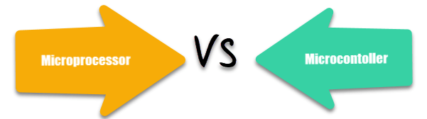

|  |  |
| --- | --- |
| **Microprocessor** | **Microcontroller** |
| Microprocessor is the heart of Computer system. | Micro Controller is the heart of an embedded system. |
| It is only a processor, so memory and I/O components need to be connected externally | Micro Controller has a processor along with internal memory and I/O components. |
| Memory and I/O has to be connected externally, so the circuit becomes large. | Memory and I/O are already present, and the internal circuit is small. |
| You can’t use it in compact systems | You can use it in compact systems. |
| Cost of the entire system is high | Cost of the entire system is low |
| Due to external components, the total power consumption is high. Therefore, it is not ideal for the devices running on stored power like batteries. | As external components are low, total power consumption is less. So it can be used with devices running on stored power like batteries. |
| Most of the microprocessors do not have power saving features. | Most of the microcontrollers offer power-saving mode. |
| It is mainly used in personal computers. | It is used mainly in a washing machine, MP3 players, and embedded systems. |
| Microprocessor has a smaller number of registers, so more operations are memory-based. | Microcontroller has more register. Hence the programs are easier to write. |
| Microprocessors are based on Von Neumann model | Micro controllers arc based on Harvard architecture |
| It is a central processing unit on a single silicon-based integrated chip. | It is a byproduct of the development of microprocessors with a CPU along with other peripherals. |
| It has no RAM, ROM, Input-Output units, timers, and other peripherals on the chip. | It has a CPU along with RAM, ROM, and other peripherals embedded on a single chip. |
| It uses an external bus to interface to RAM, ROM, and other peripherals. | It uses an internal controlling bus. |
| Microprocessor-based systems can run at a very high speed because of the technology involved. | Microcontroller based systems run up to 200MHz or more depending on the architecture. |
| It’s used for general purpose applications that allow you to handle loads of data. | It’s used for application-specific systems. |
| It’s complex and expensive, with a large number of instructions to process. | It’s simple and inexpensive with less number of instructions to process. |